Name: Sharma Raj Bablu
Roll.no: 41
Division: SE-3 / S3
Branch: C.S.E(D. S)
Subject: M.D.M
EXPERIMENT NO.09
Aim: - Implement search functionality to filter API results dynamically.
Code:
<!DOCTYPE html>
<html>
<head>
<title>Live Post Finder</title>
<style>
body {
font-family: Verdana;
background: linear-gradient(to right, #e3f2fd, #ffffff);
}

h2 {
text-align: center;
color: #333;
}

input {
display: block;
margin: 20px auto;
width: 320px;
padding: 10px;
border: 2px solid #2196f3;
border-radius: 5px;
}

#count {
text-align: center;
font-weight: bold;
color: #555;
}

.box {
background: #fff;
margin: 15px auto;
padding: 15px;
width: 60%;
border-left: 5px solid #2196f3;
box-shadow: 0px 2px 5px rgba(0,0,0,0.1);
}

.box h3 {
color: #2196f3;
}
</style>
</head>

<body>

<h2>🔍 Live Post Finder</h2>

<input type="text" id="search" placeholder="Type to search posts...">

<p id="count"></p>

<div id="results"></div>

<script>
let apiData = [];

// Fetch API
fetch("https://jsonplaceholder.typicode.com/posts")
.then(res => res.json())
.then(data => {
apiData = data;
showData(apiData);
});

// Display function
function showData(data) {
const resultDiv = document.getElementById("results");
const count = document.getElementById("count");

resultDiv.innerHTML = "";
count.innerHTML = "Results Found: " + data.length;

data.forEach(item => {
resultDiv.innerHTML += `
<div class="box">
<h3>${item.title}</h3>
<p>${item.body}</p>
</div>
`;
});
}

// Search filter (title + body)
document.getElementById("search").addEventListener("keyup", function() {
const value = this.value.toLowerCase();

const filtered = apiData.filter(item =>
item.title.toLowerCase().includes(value) ||
item.body.toLowerCase().includes(value)
);

showData(filtered);
});
</script>

</body>
</html>

Output: -
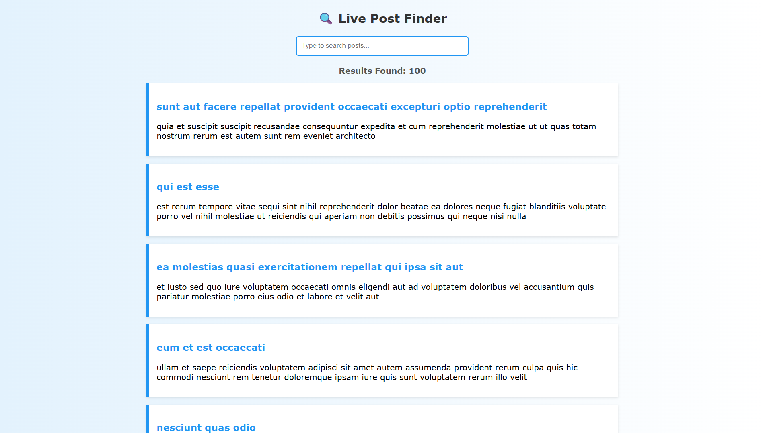

Conclusion: -
Thus, a simple counter application was successfully developed using React Hooks. The experiment demonstrates the use of useState for state management and useEffect for handling side effects. This approach simplifies component logic and improves code readability in modern React applications.

Questions: -
- What is dynamic search filtering?
Dynamic search filtering is a technique where data is filtered in real-time based on user input without reloading the page.
As the user types in the search box, the displayed results update instantly.
Key Points:
  - Works on client-side data
  - Uses functions like .filter()
  - Provides instant results
- How is DOM manipulation used in this experiment?
DOM manipulation is used to update the displayed data dynamically on the webpage.
🔹 How it happens:
  - User enters text in input field
  - JavaScript/React updates state
  - Filtered data is generated
  - The DOM is updated to show only matching results
In React:
  - DOM updates happen automatically (Virtual DOM)
In JavaScript:
  - Elements are manually updated using:
document.getElementById() element.innerHTML
- Why is page reload not required?
Page reload is not required because:
  - Data filtering happens on the client side
  - JavaScript/React updates the UI dynamically
  - Only specific parts of the page are updated
Reason:
React uses Virtual DOM, which:
  - Detects changes
  - Updates only required elements
  - Avoids full page refresh

